**Literature Survey**

**1. New full Iris Recognition System and Iris Segmentation Technique**

**Using Image Processing and Deep Convolutional Neural Network**

This paper introduces a new and full system for Iris recognition which begins by eye detection and then iris detection and if the image successfully passes these steps it will pass through iris segmentation step and the final step is iris classification using convolutional neural networks. This paper introduces a new iris segmentation method to extract features from the image.

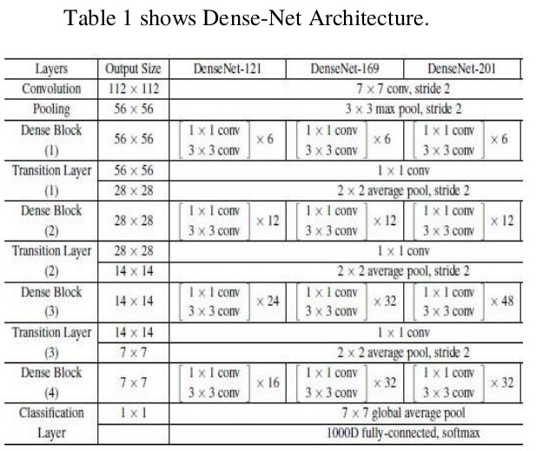



Thepaper uses the different architectures of models to train the model for iris recognition.

Conclusion:

This paper proposed a new iris recognition system which performs high accuracy on different public datasets. The paper also proposes a new iris segmentation method which affects the final accuracy on each dataset. The performance of the proposed iris recognition model is better than other methods. the newly proposed iris segmentation method performs high accuracy which makes significant results in the classification step. All the methods on iris recognition focus on iris classification and iris segmentation but there are no methods focus on steps before that in this paper the proposed method takes a full journey from identifying the eyes to detecting iris then extracting iris features then classify the iris so the proposed iris recognition system is

A full method which can be tested on any types of image.

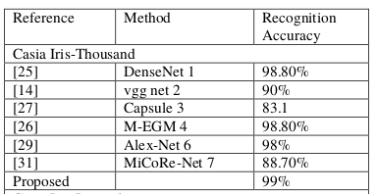

**-------------------------------------------------------------------------------------------------------------------------------**

**2. DeepIris: Iris Recognition Using A Deep Learning**

**Approach**

In this pater Iris recognition is based on residual Convolution Neural Network.

This paper propose an iris recognition framework based on transfer learning approach. It proposed a transfer learning approach to perform identity recognition using a deep residual convolutional network. It used a pre-trained ResNet50 model trained on ImageNet dataset, and fine-tune it on our training Images.

To perform recognition on iris dataset, it fine-tuned a ResNet model with 50 layers on the augmented training set.

The overall block-diagram of the ResNet50 model, and how it

is used for iris recognition is

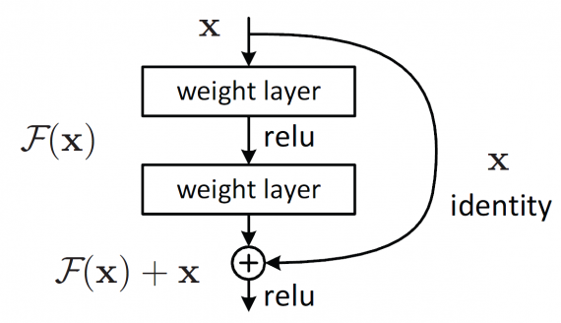

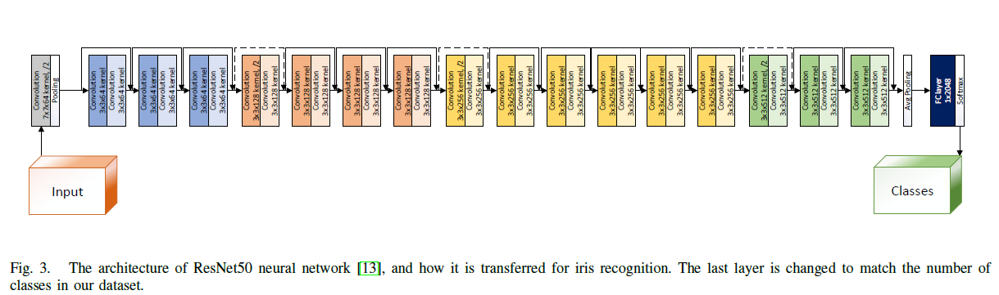

It trained the proposed model for 100 epochs using an Nvidia Tesla GPU. The batch size is set to 24, and Adam optimizer is used to optimize the loss function, with a learning rate of 0.0002. All images are down-sampled to 224x224 before being fed to the neural network. All implementations are done in PyTorch with accuracy of 95.5%.

Conclusion :

In this paper , propose a deep learning framework for iris recognition, by fine-tuning a pre-trained convolutional model on ImageNet. This framework is applicable for other biometrics recognition problems, and is specially useful for the cases where there are only a few labeled images available for each class. Paper applied the proposed framework on a wellknown iris dataset, IIT-Delhi, and achieved promising results, which outperforms previous approaches on this datasets. It trained these models with very few original images per class. It also presented a visualization technique for detecting the most important regions while doing iris recognition.

-------------------------------------------------------------------------------------------------------------------------------

**3. A Computer Vision System for Iris Recognition**

**Based on Deep Learning**

In this paper, deep learning has been used to recognize iris patterns of various users . The technique is explored by using Convolutional neural networks, which make use of filters and learning of weights via backpropagation.An important aspect, known as hyperparameter optimization of network architecture is considered, along with the use of an appropriate filter weights to provide an efficient framework for iris recognition.While hyperparameters like number of filters, strides and padding are given importance in proposed architecture, filter optimization using backpropagation is analyzed by using different optimization techniques.

Authors have worked on four approaches to identify iris patterns. These are Haar Wavelet, Gabor filter, Discrete Cosine Transform and Fast Fourier Transform. Identification using Log Gabor Filter gives the best performance out of these approaches.A statistical feature extraction technique based on Hamming distance and pixel correlation has been devised for efficient iris recognition.

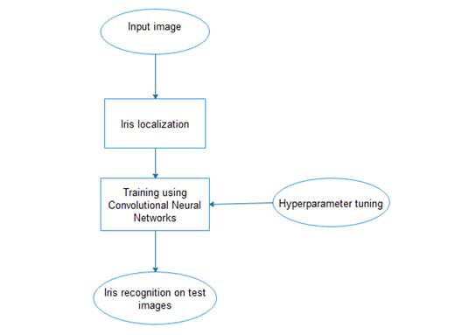

Proposed model architecture

The main steps followed in the proposed training architecture

are:

1. Division into training, validation and test set.

2. Use the described hyperparameters to train the CNN.

3. Evaluate the configurations using validation.

4. The number of epochs have been set to 100.

5. Repeat these steps through 100 epochs.

6. Choose the configuration giving minimal error using

validation.

7. Evaluate this configuration using the test set.

Results :

The performance of this proposed architecture has encouraging results i.e. an accuracy of 98 % is achieved.



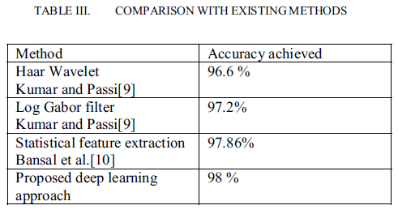

Conclusion :

In this paper, proposed system an iris recognition system using deep learning approach, which authenticates a person’s identity. The proposed system by applying localization to iris

using Hough transform, followed by automatic feature extraction using CNN. of the same person. The overall accuracy is increased by hyperparameter tuning and the processing time is reduced.

-------------------------------------------------------------------------------------------------------------------------------

**4. CONVOLUTIONAL NEURAL NETWORK BASED**

**FEATURE EXTRACTION FOR IRIS**

**RECOGNITION**

The proposed iris recognition system using the Convolutional Neural Network (Alex Net) for

feature extraction, The development of the proposed iris recognition system is discussed in three parts: the pre-processing stage, feature extraction stage, and classification stage.

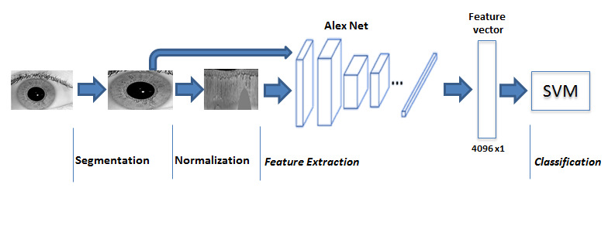

This paper evaluated the extracted learned features from a pre-trained Convolutional Neural

Network (Alex-Net) followed by multi-class SVM algorithm to perform iris recognition. The iris

is segmented using circular Hough transform and normalized using rubber sheet model. The

segmented and normalized image is fed as an input to the CNN (Alex-Net). The proposed system is tested on public datasets (IITD iris databases, CASIA-Iris-V1, CASIA-Iris-thousand, and CASIA-Iris- Interval), and a high accuracy rate is achieved. The results showed that the

recognition accuracy when extracting features from the segmented image is higher than when

extracting features from the normalized image.

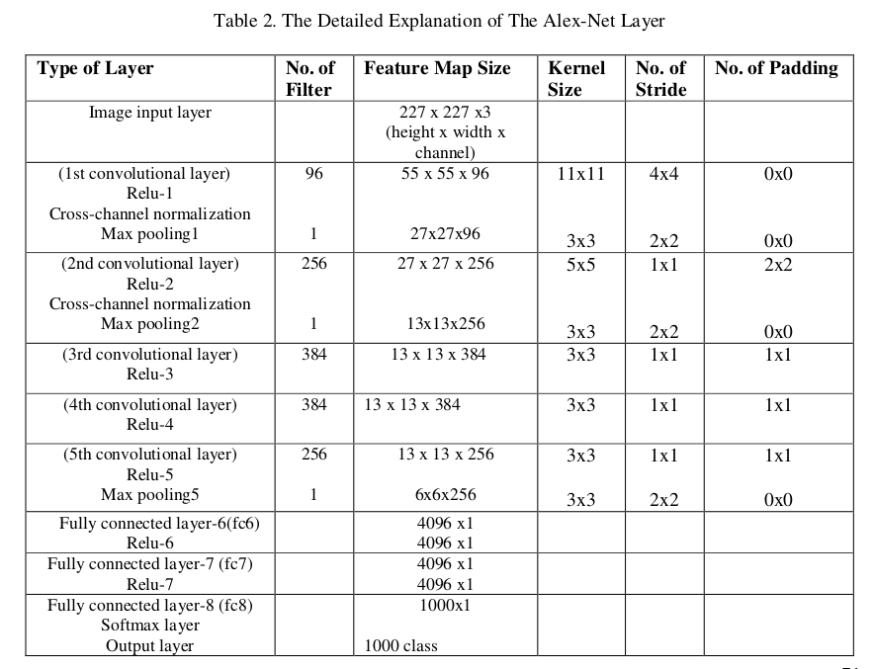

Below is the accuracy of proposed model for various datasets:

